1. **Scenario**: Building a directive that highlight the element we hover over. 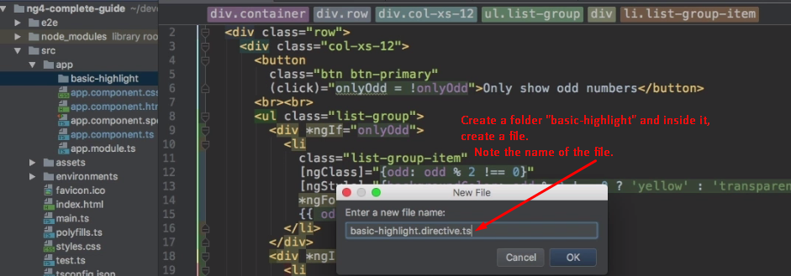
2. **We** need to pass a configuration object to **@Directive**.
   1. Properties of the Configuration Object.
      1. **selector**: We do place our directive inside template to attach it to element. Must be unique. Camel Case notation usually. 
      2. Now the element on which the directive would be applied, we want access to that. Angular gives us this access. We can inject that element on which directive sits.  
         How to access the element which is garnished with **directive**.  
         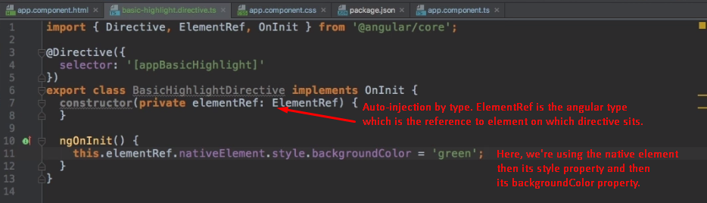
      3. Informing angular about our directive.  
         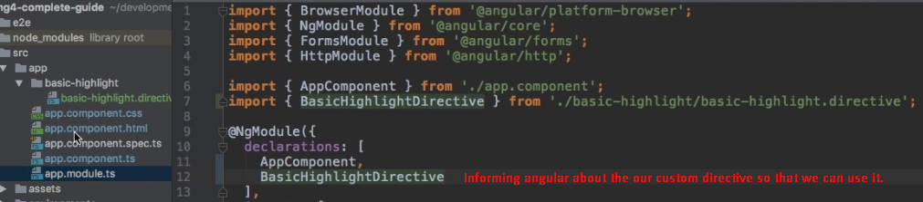
      4. 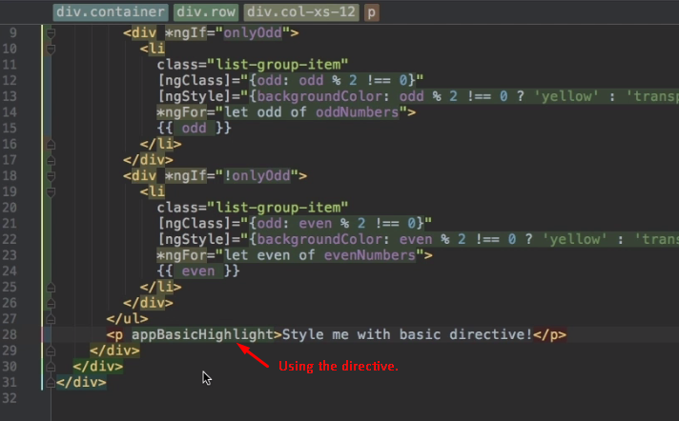
      5. See the directive did its magic. 🡸Greening.   
         